NOTES FOR OUTER HEBRIDES RIFG MEETING ON FRIDAY 31 JANUARY 2025

MATTERS ARISING MEETING 7 MARCH 2024

No further update on the evaluation of the RIFGs had been received from Marine Directorate.

Only 3 measures of the original consultation paper had been introduced on 12 May 2024:

- prohibit a commercial fishing vessel from retaining onboard, landing, offering for sale or consigning a berried (egg bearing) lobster

- prohibit a commercial fishing vessel from retaining onboard, landing, offering for sale or consigning a berried (egg bearing) brown crab

- prohibit a commercial fishing vessel of greater than 12 metres overall length, that caught over 200 tonnes of brown crab and/or lobster during any 12 month period(s) from 2020 onwards from deploying creels, pots or traps within any part of Scottish inshore waters (0-6 nautical miles), with the exception of the inshore waters surrounding St Kilda (Hirta and Boreray), Flannan Isles, Rockall, Sula Sgeir, North Rona, Sule Stack, and Sule Skerry

Agenda will cover a summary of feedback from industry since the introduction of the interim measures.

There have been no reports of increased effort in the pot limitation area since monitoring had ceased.

Meetings have been held with St Andrew’s University regarding the CatchApp and those involved have provided positive feedback.

Prawn tail prices have increased with skippers providing additional information to processors, which will be used as part of the accreditation process.

Due to poor weather conditions over the summer of 2024, it was not possible to plan ahead for observers aboard vessels, with only observed trip taking place at the Shiants with vessel using tangle nets.

Discussions continue at local level regarding possible improvements in onshore infrastructure to accommodate additional landings of various white fish and pelagic species for added onshore processing prior to being frozen down prior to exported.

Delays experienced with additional vessel participating in electro fishing in the Uists those seem to have been resolved with a suitable vessel now identified.

1.

A 3 week introduction to commercial fishing course was completed in late 2024 with 8 attending and all receiving placements, positive feedback from candidates and its hoped to run a further course in March or May, with good interest being shown for attending the course. Discussions are taking place with one of the candidates who has identified an under 10 metre vessel that he wishes to purchase, with a requirement to complete a GMDSS radio operators certificate being necessary before any further transactions can be completed.

Further meetings have been held with Northland who are proposing to develop the fixed bed turbines in inshore waters to the West of Lewis. A new project Director has been appointed and early fisheries meeting will be held with the new Director. If the project proceeds a Community Benefit agreement has been reached with the Community landlords adjacent to the development for £4.5M annually index linked for 35 years.

CHAIRMAN VERBAL UPDATE

Chairman will provide a verbal update on his various meetings.

NORTH EAST LEWIS MPA RISSO’S DOLPHIN MONITORING

The following table and maps detail the proposed locations for deployment of 6x NatureScot acoustic moorings within the North-east Lewis MPA from Apr/May 2025. Figure 1 shows the proposed locations of acoustic moorings with MPA boundary. Figures 2-4 show the locations of these moorings with VMS fishing activity data available from ICES.

Depth and lat/long details of each acoustic mooring:

Mooring name | Latitude (DD) | Longitude (DD) | Approx. depth (m)
Butt of Lewis | 58.601147 | -6.188471 | 130
Offshore North MPA | 58.517661 | -6.042712 | 90
Tiumpan Head | 58.25720 | -6.11810 | 82
Bayble offshore | 58.164247 | -6.121401 | 125
Braighe | 58.185053 | -6.298333 | 25
Offshore South MPA | 58.104790 | -6.27965 | 98

- The Braighe mooring (x1) is proposed to be surface buoy marked. All other moorings (x5) are proposed to use a sub-surface mooring recovery system.

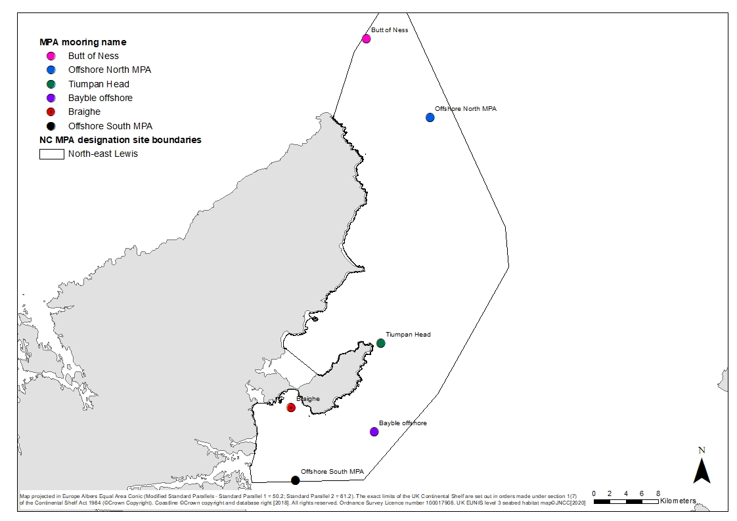
Figure 1: Map of the six NatureScot proposed acoustic mooring locations.

Maps of NatureScot acoustic moorings and fishing activity data

Key for each map:
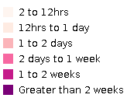

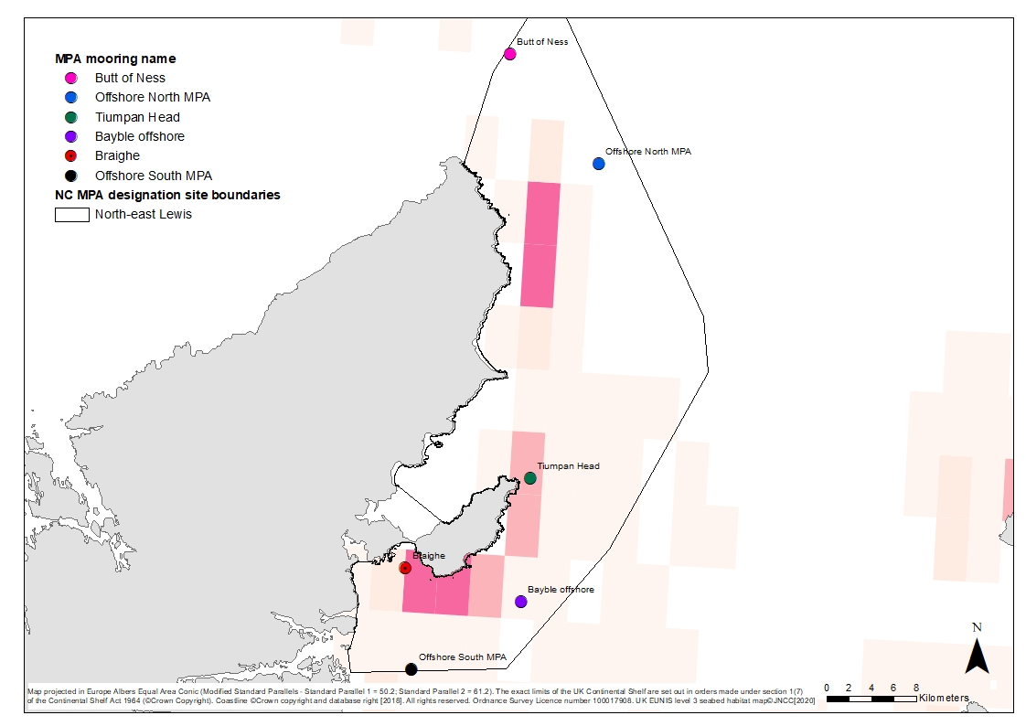

Figure 4: VMS Fishing intensity – average intensity (hours) of fishing with dredges (2009-2017). IC

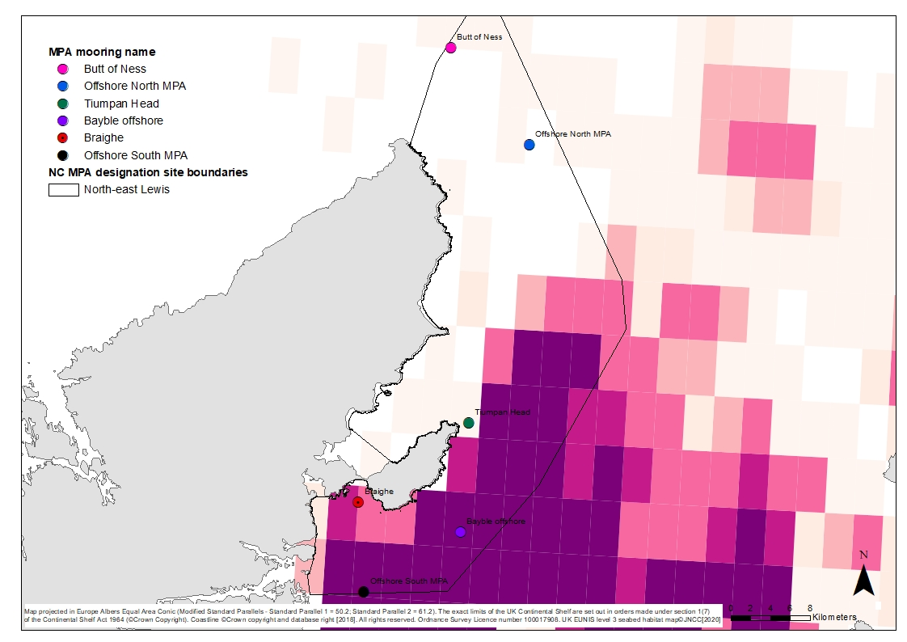

Figure 2: VMS fishing intensity – average intensity (hours) of fishing for nephrops and crustaceans with bottom trawls (2009-2017). ICES.

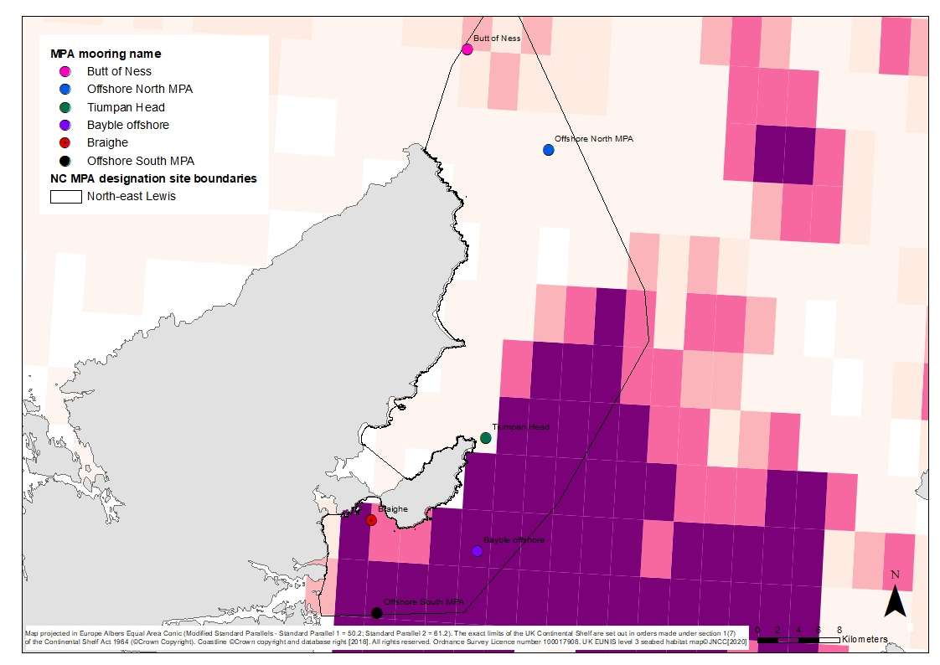

Figure 3: VMS fishing intensity – average intensity (hours) of fishing with bottom trawls (2009-2017). ICES.

Initial feedback from trawlers indicate that Bayble Offshore will be towed, due to extensive prawn trawling in the area, with alternative position being suggested by skippers to coincide with a local wreck within a mile, with lat long positions expected to be available shortly. In addition, the Offshore South MPA could also present problems due to high concentrations of fishing effort.

Whilst the VMS data is rather old, its likely that similar levels of nephrop trawl effort take place within the designation , coupled with similar levels of static gear effort and possibly reduced scall dredge effort.

An agreed timetable to be agreed on length of time moorings will be inside the MPA and arrangements should be reached with industry on exact locations, so that any sites in danger of being snagged can be shifted to safer areas.

FUTURE DESIGNATIONS, PMFs, MANAGEMENT WITHIN EXISTING SITES

Meetings have been held throughout the Western Isles at which members involved in netting methods have met with officials from Marine Directorate and Nature Scot.

Evidence of bird interaction presented related to data from South West England and Europe with little information provided from around Scotland.

The main purpose of those meetings was to identify areas that are and have been commercially fished with nets for white fish and crawfish, that are within marine sites that have already been designated for various reasons. However, they currently have no fisheries management measures within those sites. It’s clear that MD intend to introduce management within those sites and go out for formal consultation sometime in 2025.

The main areas identified have been the areas out to 6 miles to the West of the Hebrides from Sound of Harris to South of Barra, Flannan Isles, Shiants, North Rhona and Sula Sgeir.

It was considered that inshore areas to the East of Uist and Harris currently used with small mesh to target herring and mackerel did not seem to present a problem.

Feedback at all meetings made reference to the over-abundance of sea eagles in Lewis and Uist that are now killing more birds that any commercial fishing activity with nets. Nature Scot

Following those meetings discussions have taken place between Marine Directorate and Sea Mammal Research Unit who are based at St Andrew’s University, so that arrangements can be made for observers to go aboard netting vessels during the summer season.

5.

Members from Barra, South Uist, Harris and Lewis who currently use tangle nets for crawfish have noted that they are willing to take observers aboard to observe their fishing operations.

The Sea Mammal Research Unit has been in touch and keen to have observers at sea for around 40 days once the netting fishery commences in 2025.

In addition to netting, the Sound of Barra and a significant number of areas of Priority Marine Features mostly on the West Coast of Scotland and around the Western and Northern Isles are scheduled for consultation this year.

Those areas have appeared on previous charts over recent years and it’s hoped that a pragmatic approach in reducing the size of those areas and more zoning of the features is undertaken to reflect plotter tracks provided and accurate use of REM cameras aboard scallop boats.

Members should note the above and industry should expect additional correspondence to appear from Marine Directorate in 2025.

PRESENTATION ON ENTANGLEMENT PROJECT

Susannah Calderan will provide a short presentation on the entanglement project run by the Scottish Entanglement Alliance (SEA). SEA is a partnership of fishing, research, academic and NGO groups, working to together to better understand whale and basking shark entanglement issues in Scottish fisheries.

For the past two years, we have been running a trial of negatively buoyant rope in the Nephrops, crab and lobster creel fisheries in the Inner Sound and south Skye area to see if this change, which would remove the loops of rope between creels which can entangle whales and basking sharks, would be practical for fishermen.

The project has been run as a bottom-up, collaborative partnership with the fishermen involved, and has been very successful. They have found negatively buoyant rope to be practical to use, in many cases preferring it to standard floating rope in groundlines.
We now want to explore the options for how negatively buoyant rope in creel groundlines might be implemented around Scotland in the inshore creel fleet. For that, we are planning a series of workshops around the coast to talk to fishermen and other stakeholders about our work so far, and gather their input.

An important part of the process will be a socio-economic analysis of how negatively buoyant rope might be implemented in a way that is fair for fishermen. We want this process to continue to collaborate with them to find a way forward, and understand how the use of sinking rope might vary across areas and fisheries.

Workshops will be held in the Dark Island Hotel, Benbecula on Wednesday 12th February at 6pm and in the Harris Hotel on Thursday 13th February at 6pm

6.

FEEDBACK ON INTERIM SHELLFISH MANAGEMENT MEASURES

Meetings were held throughout the Western Isles to ascertain feedback from fishermen, as to impact of interim shellfish management measures had on their business since introduction on 12th May 2024 as follows:

- prohibit a commercial fishing vessel from retaining onboard, landing, offering for sale or consigning a berried (egg bearing) lobster

- prohibit a commercial fishing vessel from retaining onboard, landing, offering for sale or consigning a berried (egg bearing) brown crab

- prohibit a commercial fishing vessel of greater than 12 metres overall length, that caught over 200 tonnes of brown crab and/or lobster during any 12 month period(s) from 2020 onwards from deploying creels, pots or traps within any part of Scottish inshore waters (0-6 nautical miles), with the exception of the inshore waters surrounding St Kilda (Hirta and Boreray), Flannan Isles, Rockall, Sula Sgeir, North Rona, Sule Stack, and Sule Skerry

Summary of written feedback from skippers reflect the impact on their business, during a period of reduced days at sea to the West due to one of the worse summer weather on record.

One Barra vessel returning 1431 berried lobsters from the start of the prohibition until gear moved east in mid-October, reckoning that had the ban been in place from the beginning of season then return of berried lobsters would have been in excess of 2 tonnes.

Another Harris skipper had returned 891 before the end of October at an estimated weight of 640Kgs, although had used the option of fishing prawns as well. Having moved east of the seasonal closure on 1 November and hauled 560 pots 3 times in a week, retaining 403 lobsters for 280Kgs and returned 262 berried lobsters nearly 40% at 180Kgs, worth £3,600 at value if sold. On fourth day returned 91 berried similar percentage, retained 132 lobsters. in addition, returning in every fleet of 40 pots from 25-50 undersized lobsters 80mm+range, showing good return of undersized. Having marked berried lobster with special band mark none had been re-caught.

Single handed vessels that only target lobsters have had a disproportionate economic impact, as they do not have alternative species, as some have wrasse, velvet or brown crab or nephrops and they can’t afford to purchase additional gears to balance out their economic loss.

7.

Another Harris skipper reported poorest summer of weather experienced since starting fishing:

May - 9 days June - 4 days July - 9 days Aug - 2 days Sept - 9 days
Total - 28 full days fishing, 5 part days taking gear ashore.

Number of creels fished : 236
Lobster landed : 2987kg
Berried returned : 697kg -19%
Value of Berried Returned : £9116.60

In addition, a further 350kg - 10% of whole total caught of crippled/v notched lobster were returned and aren’t reflected in the figures, nearly 30% of catch being returned

Skipper had priced a replacement engine in March, coming in at £21,500. Did not proceed with engine due to lost income due to prohibition on landing berried lobsters.

His comment on response was conservation measures fought for and introduced locally had been a resounding success. We just didn’t need any more.

Another recently married Harris young fish time vessel owner, was in the process of going offshore, as could not absorb the loss of income and was unable to purchase additional gear to compensate for the loss of income. He did not have any gear for flexibility to fish for other species.

The only buyer that provided notification of lobster purchases in the week prior to the prohibition stated that he would have bought 21% less berried lobsters by weight had the prohibition been in place. That ranged from the highest vessel being at 35% to a lower level of 15%.

At all meetings held throughout the Western Isles poor summer weather was highlighted resulted in less days at sea than normal to the West of the Hebrides.

In Harris, some of the skippers could work around the prohibition, as they had alternative species that they could target, whilst those solely dependent on lobsters were struggling to survive. They highlighted that some merchants indicated that there was a resistance to some UK buyers buying berried lobsters, with Southern Ireland undertaken a large v-notching programme of berried lobsters for which BIM were paying the fishermen. More crippled lobster appearing in parlour pots, with some indicating that existing measures would suffice, as Western Isles vessels were suffering more than other areas due to management measures already in place.

Would have been useful to have had feedback on benefits from England where prohibition on landing berried lobsters had been introduced several years previously.

8.

Some vessels had flexibility to haul pots for either wrasse of nephrops in the Minch, when they could not fish lobster and crab to the West. Many of the smaller class of vessels are solely dependent on lobster and crab and had no alternative fisheries so were negatively impacted more than others with greater flexibility.

One skipper reporting that feedback from England was that many skippers are scrubbing lobsters and vessels not scrubbing are losing their crew to vessels that are scrubbing, as crew are getting better wages on those vessels.

Similar feedback in Stornoway to Harris with vessels there reporting higher catches of brown crab compared to previous years, possibly following from the ban on vivier vessels inside 6 miles. Those solely dependent on lobsters totally opposed to the prohibition, as they had seen a significant increase in stocks over the years following nearly 30 years of seasonal creel prohibition closures, v-notching, increase in MLS.

Meetings in both Barra and Uist showed little support of the prohibition on landing berried females, skippers attending were heavily dependent on lobster fishery, already restricted due to seasonal closures of the main grounds. Most of the lobster landings in the Western Isles being taken from the grounds to the West of Uist and Barra.
Lobster catches have been better there than they were 50 years ago, following a decline in stocks for a period after the deeper virgin grounds with larger brood stocks had been fished hard by Channel Isles vessels. The inshore grounds took many years to recover with stocks improving to current high levels following an extensive v-notching programme over 20 years previously, couple with increasing the MLS and decreasing the MaxLS for females and the ban on landing crippled females. Many continue to v-notch lobsters which are released and remain on the grounds.
They were of the opinion that current management measures in place in the Outer Hebrides was a good example of regional management measures coming from fishermen on the grounds, rather than blanket one size fit all measures for the whole of Scotland, with varying types of lobster grounds and size distribution. Some skippers were reporting in excess of 50% throw backs early in the summer and in late autumn.

They saw great merit in the promotion of the good practices that are taking place locally, resulting in healthy stocks at a time when the Good Food Guide is telling the public that lobster stocks are in poor health and should not be bought. This was certainly not the case or experience of fishermen around Uist where lobster stocks are in very healthy condition.

Those involved in lobster storage did not purchase lobsters to the same extent as in previous years due to the uncertainty of legislation of lobster developing eggs in storage and not being able to sell those on for the Xmas market. They indicated that by live storage buyers not buying earlier in the year for storage, this kept the price down in the summer months, causing further economic loss to the fishermen. Had they been buying they were confident that prices would have been at least £2/kilo higher.

9.

The inshore lobster grounds to the East of the Uists are now yielding higher catches of lobster than ever before, which buyers think could be due to hatched lobster eggs being released into the sea from storage tanks during storage over the last 30 years. Those buyers have seen some of their stored female lobsters now appearing with eggs since they have gone into tanks and are unsure how the buyers are going to consider buying those lobsters for the Xmas market, or will they get reduced prices for those berried lobsters.

There was unanimous support at all meetings that the prohibition on viviers operating inside 6 miles remain in place and would be beneficial to the recovery of brown crab stocks on the inshore grounds. Those vessels had been built to fish offshore grounds as was now evident with many of the UK registered vivier crabbers fishing the offshore grounds in the North Sea.

The landings of lobster in the Western Isles in 2023 being the largest tonnage landed since 2015, despite the increase in MLS, ban on crippled females and reduction in MaxLS for females and the prohibition on landing v-notched lobsters since the introduction of legislation that prohibits the landing and selling of v-notched lobsters.

The Regional Inshore Fisheries Groups have developed a monkey survey to provide an opportunity for all those connected with the fisheries sector to complete a survey relating to the current interim shellfish management measures.

Please note that this survey is completely different from the Call for Evidence that the Scottish Government has launched and has a closing date of 18 February 2025, details of which have been circulated to anyone who wish to complete themselves.

The link to the survey is below:

https://www.surveymonkey.com/r/8SP6YB7

CALL FOR EVIDENCE

The Marine Directorate Call for Evidence opened for 10 weeks and closes on 4th February 2025, however a further 2 week extension has been given with the new closing date being 18th. The Call for Evidence offers an opportunity for anyone to submit their views on how a more regional approach could be considered for future inshore fisheries management, rather than a one size fits all approach covering Scotland.

This Call for Evidence is in addition to Interim shellfish Management measures and whilst a questionnaire has been circulated relating to the Interim measures this Call for Evidence is separate from that questionnaire.

Based on previous years of IFG involvement considerable progress has been made in managing inshore fisheries in inshore waters around the Outer Hebrides with some issues for continued consideration on how matters can be progressed in the future.

10.

- Well managed, profitable and sustainable IFG fishery
- An attractive industry with a clear career pathway for new entrants to join
- Marine Directorate first time vessel ownership scheme
- CNES Fisheries Investment Scheme
- CNES Community Quota Scheme
- 3 Week Introduction to commercial fishing Scheme
- Pilot a pot limitation scheme using low cost trackers, little maintenance with low transmission charges
- Improvements in catch per unit effort in pot pilot
- Additional local measures in reducing MaxLS for female and prohibition on landing crippled females
- Improving quality of the catch aboard vessels
- Ice provision at remote locations to aid diversification
- Strategic processing facilities to add value locally, live storage facilities
- Flexibility in under 10 metre sector licencing
- Proportionate allocation of Blue Fin Tuna Licences to Scotland
- Piloting of Rural or Island Visa for Scotland
- Relaxation of Medical requirements for Inshore Waters of Scotland freeing waiting times for doctors to treat sick patients
- Introduction of permits in some fisheries, wrasse, razors, pot limitation scheme
- Seasonal closures for pot prohibition areas
- Seasonal scallop closures for all methods working well
- Improvements in quality of stock in brown crab and cockles for fisheries with previous poor yield
- More research required on all year closures, Broad Bay for juvenile place
- Better zoning of features required to prevent unnecessary large area closures as was evident in Wester Ross MPA and Mingulay Reefs MPA, with better use of technology to reopen areas that should not have been closed.
- Improved community engagement in future marine designations
- Some form of Seal Management Planning
- Improvements in data collection in inshore, better use of CatchApp coupled with tracking systems that should gather more data for science rather than solely for enforcement
- Improved branding for seafood e.g. Hebridean Langoustines
- Increased seafood presence in schools
- Case studies to demonstrate success amongst young fisheries
- Improved engagement with Marine Renewables to ensure community benefit

11.

- Develop simple cost effective tracking devices for small vessels
- Improved management of spurdog fishery
- Explore benefits of increase in minimum landing sizes, lobsters from 87 -90mm and scallops from 100 – 105mm
- Further research to open additional razor fish grounds with zoning as previously done in Sound of Harris to avoid seagrass, could be considered for Sound of Barra
- Investigate development of cockle fisheries on beaches within designated areas
- Investigate how additional quotas could be distributed to inshore fleet to enhance opportunities to regenerate coastal communities from high dependency on shellfish
- Industry participation in onboard scanning system as currently being developed at St Andrew’s University to gather accurate shellfish stock assessments, reducing the need for so many observers aboard fishing vessels
- Continuation of work with Herriot Watt University to ascertain improvements to reduce impact on seabed, improve fuel efficiency
- Development of Fisheries Management Plans to reflect the needs of regional communities
- Tonnage restrictions on larger mobile vessels operating in inshore waters as already evident in management of an MPA
- Regional Marine Plans to be developed without any further delays
- Improve current legislation covering unlicensed fishermen
- Use of drones and fast ribs to improve patrolling of inshore waters
- Ensure any new regulations consider operating costs of new vessels
- Development of West Coast Nephrops fishery to optimise available TAC
- Improved marking of static gear and removal of unfished and unmarked gear
- Consideration given to high cost of static gear compared to other inshore fishing methods, in many cases exceeding the value of vessels when assessing profitability of the inshore fleet

The above is a summary of matters that have been considered over the years at IFGs meetings and could be raised in any response to the call for evidence and members are asked to consider the above and any other additional measures that could be considered in the Call for Evidence.

12.

LATEST LANDINGS INTO WESTERN ISLES

Publication of official Scottish landings statistics for 2023 were published in December and showed a significant increase in value for the Western Isles.

 |  |  | LANDINGS INTO WESTERN ISLES IN 2023
 |  |  |  | Tonnage |  |  |  |  | Value
 |  | 2019 | 2020 | 2021 | 2022 | 2023 | 2019 | 2020 | 2021 | 2022 | 2023
Stornoway | Total demersal | 116 | 124 | 100 | 93 | 64 | 3,284 | 1,597 | 1,318 | 888 | 1,002
Stornoway | Total pelagic | 3 | 15 | 7 | 1 | 0 | 5 | 22 | 8 | 2 | 2
Stornoway | Edible crabs | 1,001 | 550 | 488 | 502 | 621 | 2,376 | 972 | 1,096 | 1,187 | 1,422
Stornoway | Lobsters | 180 | 162 | 159 | 152 | 181 | 2,473 | 2,017 | 2,379 | 1,947 | 2,382
Stornoway | Nephrops | 1,065 | 926 | 1,374 | 1,399 | 1,484 | 5,289 | 3,772 | 5,592 | 6,769 | 7,103
Stornoway | Razor fish | 28 | 10 | 12 | 20 | 27 | 234 | 79 | 111 | 192 | 276
Stornoway | Scallops | 579 | 523 | 522 | 580 | 526 | 1,419 | 1,034 | 1,075 | 1,305 | 1,219
Stornoway | Velvet crabs | 279 | 229 | 202 | 205 | 158 | 841 | 596 | 624 | 588 | 483
Stornoway | Other shellfish | 28 | 17 | 17 | 10 | 10 | 71 | 27 | 49 | 48 | 27
Stornoway | Total shellfish | 3,160 | 2,416 | 2,773 | 2,868 | 3,007 | 12,702 | 8,497 | 10,926 | 12,036 | 12,913
Stornoway | Total landings | 3,280 | 2,556 | 2,880 | 2,963 | 3,071 | 15,990 | 10,116 | 12,252 | 12,926 | 13,916
MAIN OBSERVATIONS TO NOTE:
Overall value up by 10.85%
Total Demersal value up £1.002 M from £888K main species in that category relates to wrasse
Brown crab value up to £1,4222 from £1.187 tonnage up to 621 tonnes 502 tonnes highest since 2019
Lobsters value up to £2.382M from £1.947 tonnage 181 from 152 highest tonnage in last 16 years
Nephrops value up to £7.103M from £6.769M tonnage up to 1,484 from 1,399 amd highest since 2016
Razor Fish value up £276K from £192K tonnage up 27 tonnes from 20 tonnes and highest since 2019
Scallops down to £1.219 M from £1,305M tonnage down 526 tonnes from 580 tonnes less local vessels
Velvet Crab down to £483K from £588K tonnage to 158 tonnes from 205 tonnes lowest in last 16 years
Price per tonne |  | 2022 |  | 2023
Brown Crab |  | 2, 365 |  | 2,290
Lobster |  | 12,809 |  | 13,160
Nephrops |  | 4,838 |  | 4,786
Razor Fish |  | 9,600 |  | 10,222
Scallops |  | 2,250 |  | 2,317
Velvet Crab |  | 2,868 |  | 3,057
 |  |  |  | 13.
 | SHELLFISH TONNAGE LANDED INTO WESTERN ISLES 2023 - 2008
 | 2023 | 2022 | 2021 | 2020 | 2019 | 2018 | 2017 | 2016
 | Tonnage
Edible Crab | 621 | 502 | 487 | 559 | 1991 | 895 | 1065 | 1040
Lobster | 181 | 152 | 159 | 162 | 180 | 163 | 128 | 117
Velvet Crab | 158 | 205 | 201 | 229 | 279 | 203 | 241 | 260
Nephrops | 1484 | 1369 | 1340 | 923 | 1055 | 1126 | 1406 | 1673
 | 2015 | 2014 | 2013 | 2012 | 2011 | 2010 | 2009 | 2008
 | Tonnage
Edible Crab | 777 | 934 | 801 | 725 | 775 | 688 | 658 | 739
Lobster | 100 | 129 | 89 | 120 | 130 | 134 | 134 | 162
Velvet Crab | 245 | 264 | 237 | 286 | 268 | 286 | 283 | 257
Nephrops | 1440 | 1387 | 1554 | 1650 | 1378 | 1450 | 1759 | 2108

CNES PRIMARY INDUSTRIES MARINE PROJECTS

Iain Kennedy, Fisheries Development Officer, CNES will provide an update on the project that they are involved with throughout the Western Isles as part of the Islands Growth Deal and UK Structural Funds. Whilst the Islands Growth Deal is over a 10 year period , some of the UK Structural Funds are coming to an end shortly.

FISHERIES MANAGEMENT PLANS

The Joint Fisheries Statement agreed by the UK Government set out that the devolved administrations will all publish FMPs by 2028. Those plans will set out both short term actions and longer-term vision for the management of future stocks.

DEFRA has progressed with consulting on 6 shellfish stocks in England and Wales whilst Scotland will delay moving on shellfish stocks, whilst commencing on some white fish species.

Seafish officials have led with a number of meetings in developing the FMP for nephrops, taking into consideration both trawl and static methods and overall management.

A few WIFA members attended along with representatives from other West Coast Associations, with aims and objectives considering how stocks could be managed sustainably, in balance with impact on seabed, reducing interaction with entanglement, management by regions, reducing discards, technical improvements to gear.

14.

There was wide spread support from those attending in having a tonnage and horsepower restriction on West of Scotland grounds covering, North Minch, South Minch and Clyde areas. Such restrictions would reduce impact on muddy sediments following known damage done by use of heavy gear being towed at depth through muddy grounds damaging burrows.

Interaction with mammals was non-existent for mobile methods, although entanglement mostly with marker buoys and floating lines being noted as main cause in static methods. White fish discards with prawn trawls was low, with reduced head lines, an increased minimum mesh size, with more research required on positioning of square mesh panels.

The entanglement concerns highlighted within the static sector could be addressed by more vessels becoming involved in the current entanglement project taking place at various ports. Provision of lead ropes to participating skippers to trial in different areas would be beneficial to skippers to reduce entanglements in certain identified high risk areas.

Members are asked to note the above on Management Plans, in particular, for nephrops with Marine Directorate having delayed the process.

MORRISON ROCK & LOCH SNIZORT

According to recent reports mortality in the salmon faming industry continue at a rate in excess of 20%, with regular deposits being made to the disposal site in North Uist.

Clearly, the salmon farming industry seem to be indicating that mortalities will reduce once they are able to locate to larger offshore sites in deeper water. This shift will displace commercial fishing activity from grounds that are currently fished by mobile vessels that land their catch to local processing facilities, where additional onshore processing has been taking place for over the last 40 years.

The last remaining salmon processing facility in the Western Isles closed recently when Bakkafrost made the decision to cease landing salmon at Arnish for processing in Marybank, with all salmon now grown in the area destined for mainland Scotland. The loss of annual dues to Stornoway Port was reported to be around £300K, with economic linkage of salmon farming now greatly reduced.

All the salmon grown at Western Isles sites are now shipped to mainland ports, with Norwegian owned well boats crewed mostly be Norwegians who have a special dispensation to work in inshore waters of Scotland, which are not available to other non-EU crew in the fishing industry.

15.

Norwegian salmon interests are considering farming salmon in tunnels and this would be a welcome innovative solution to salmon farming development in future years, coupled with additional onshore processing, additional housing for employees and creating a much improved marine environment as all discharges into the sea would be closely monitored.

Some other salmon farming companies have considered harvesting in large onshore tanks, which would result in better control of discharges into the marine environment.

Looking back over the last 50 years, salmon farming has created significant economic returns to some communities throughout the Western Isles, however, despite improved connectivity forecasted for ferries the future economic linkage will be greatly reduced unless there is some guarantee in place that salmon harvested at those larger sites must be processed in the Western Isles.

Sites at Loch Snizort, Skye, Morrison Rock, Benbecula and North Kebboch have all been identified by large operators as next locations for being developed. All the sites will have major negative impact on local fisheries, with all the sites providing long term sustainable catches to local vessels, that are being processed locally

Members are requested to comment and provide indications of current levels of effort by commercial fishing vessels in the areas being proposed.

According to recent reports mortality in the salmon faming industry continue at a rate in excess of 20%, with traffic heading for disposal of dead salmon to North Uist.

Clearly, the salmon industry are of the opinion that mortalities will improve once they are able to locate to larger offshore sites in deeper water. This shift will displace commercial fishing activity from grounds that are currently fished by mobile vessels that land their catch to local processing facilities, where additional onshore processing has been taking place for over the last 40 years.

The last remaining salmon processing facility in the Western Isles closed recently when Bakkafrost made the decision to cease landing salmon at Arnish for processing in Marybank, with all salmon now grown in the area destined for mainland Scotland. The loss of dues to SPA was reported to be around £300K, with economic linkage of salmon farming now greatly reduced.

All the salmon grown at Western Isles sites are now shipped to mainland ports, with Norwegian owned well boats crewed mostly be Norwegians who have a special dispensation to work in inshore waters of Scotland, which are now available to other non-EU crew in the fishing industry.

16.

Some other salmon farming companies have considered harvesting in large onshore tanks, which would result in better control of discharges into the marine environment.

Looking back over the last 50 years, salmon farming has created significant economic returns to some communities throughout the Western Isles, However, despite improved connectivity forecasted for ferries the future economic linkage will be greatly reduced unless there is some guarantee in place that salmon harvested at those larger sites if approved must be processed in the Western Isles. Scottish Government are already insisting on pelagic vessels landing into Scotland to create additional economic linkage to Scotland.

Sites at Loch Snizort, Skye, Morrison Rock, Benbecula have been identified by large operators as there next locations for being developed. Both sites will have major negative impact on local fisheries, with both the sites providing long term sustainable catches to local vessels, that are being processed locally at Kallin and Stornoway.

Loch Snizort site has been heavily fished by trawlers from Western Isles, Skye, Kyle and Mallaig for over 50 years and provides the only sheltered fishing grounds to many inshore trawlers during periods of bad weather.

Members are requested to comment and provide indications of current levels of effort by commercial fishing vessels in areas being proposed, with links to both sites below:

https://mcusercontent.com/51ed02292979a6733fbf81314/files/b7a8032a-ecb0-b9e0-7514-6d268b380b17/BFS_Morrison_039_s_Rock_Development_Area_Comparison_A1.pdf

https://mcusercontent.com/51ed02292979a6733fbf81314/files/85fc9162-0cc6-8f81-7ee9-157446105eff/Snizort_Consultation_and_Notification_WIFAvF1_.pdf

MOUNTAIN SALMON

Mountain Salmon, a Norwegian Company, are investigating the possibility of farming salmon in tunnels and this would be a welcome innovative solution to salmon farming development in future years. They are considering additional onshore processing, additional housing for employees and creating a much improved marine environment as all discharges into the sea would be closely monitored.The type of rock required for specialised tunnelling is only evident in a site in Lewis/Harris and in Shetland. They have indicated that they could reduce mortality rates to around 3% by farming in such tunnels and could farm up to 90,000 tonnes in such an environment.

17.

Moving ashore to develop salmon farming away from the marine environment would be a welcome change, that should greatly enhance the marine environment and free up some grounds that are now fallow.

Members are asked to note the possibility of new innovative methods of harvesting salmon and other species ashore, reducing the risk of further damaging the quality of the marine environment around the cages.

LORNA JANE CY 73 EVENT

Hans Unkles, fisherman and boatbuilder for 40 years has been successfully operating the Cygnus GM21 Lorna Jane from the Scottish West coast port of Tayvallich, fishing for lobster and crab for the last 18 months with the vessel solely powered by electric. It has a sufficient battery bank to fish comfortably on a daily basis and gets recharged from shower power and/or solar. You can learn more about the boat, its capabilities and its technical capacity at https://itllneverwork.boats/

The Fishmongers’ Company of London are keen to support the future of the UK inshore fleet by presenting this concept to fishermen throughout the UK and beyond as a viable way to help support the fishing industry’s decarbonisation journey and keep seafood as the premium low-carbon source of animal protein.

To help do this, they are proposing sponsoring him to travel to different fishing ports throughout the country and discuss my hands on experience of working this boat in an honest manner, covering it’s successes and limitations. The discussion/event/presentation would involve a short intro followed by an information film then more discussion and questions then the documentary about the making of the boat and finishing with a Q&A session, total time about 2 hours. The emphasis will be on the real-world practicalities of the capabilities of this boat. We would hope to do this in the early part of 2025, i.e. January-March.

Hans is keen to travel to different areas to speak to working members of the fishing communities, suppliers and buyers.

Members are asked to note the above and considerable whether it would be useful to arrange for Hans to schedule a programme for visits to the Western Isles.

His telephone numbers are 07831181185 or 01546870221

It would be useful for all owners of Fishery Piers to attend so that they could plan ahead for future information on onshore infrastructure requirements and opportunities for grant funding towards the infrastructure costs as vessels consider moving to net zero targets.

18.

